Investigating the responses to variations in balance in an asymmetrical gameplay environment

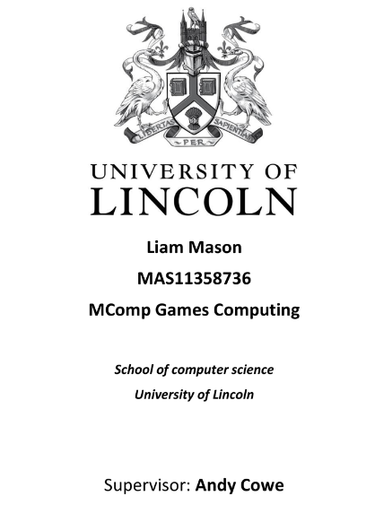

# Acknowledgements

# Abstract

Contents

**No table of contents entries found.**

# List of Tables & Figures

Figure 1: Left 4 Dead’s AI Director Gameplay overview

Figure 2:

Figure 3:

Figure 4:

Figure 5:

# 1 Project Background

## 1.1 Introduction

In the last 30 years, as a form of entertainment, video games have evolved from confined arcade activities into a mature media.

This research will explore how participants respond to variations in balance when put in a position of control. Using Virtual reality to create a disparate environment. Further, this paper will examine player’s emotional responses while playing a game specifically created for the projects purpose. This introduction will explain what balance is with in games and the way it affects how players interact with one another is an interesting area of study. BIT HERE

Balancing games has been a challenge that has plagued games forever. The term imbalanced is often heard in games, especially those of a competitive nature (Griesmer, 2010). Often players will blame the imbalance of the game for their own failure ( ). However, in some games they are intentionally imbalanced to create dynamic gameplay ( ). An example of this is the fighting game Street fighter (Capcom 2016), this often intentionally features weaker characters that players use as a challenge, a handicap or even a joke (Sirlin, 2009). Examples like this showed that imbalance could provide fun which sparked the concept of the project.

Balancing is one of the most difficult and time consuming phases of the game design process (Jaffe et al., 2012). In balancing, a playable game undergoes a tuning cycle of subtle adjustments and play testing, in an effort to improve depth, pacing, fairness, randomness and variety. Imbalanced games wouldn’t need to go through such a tedious stage allowing developers to spend time and resources elsewhere ( ). This justifies the rationale for the project.

Dungeons and Dragons (D&D) is a game in which it allows a player who is designated as the Dungeon Master (DM) to create and control the experiences of the other players. D&D has rules which essentially balance the game, which was created by the designers. However, the DM can interpret and follow these rules however they like making them fairly redundant and more of a guide (Hitchens and Drachen). Pisan (2005) describes that the power of balance between players and GM’s varies between games (Pisan, 2005). This means that different GM’s follow different rules which makes a personalizable game experience for the players in an imbalanced setting.

D&D is typically a table top game but it and others like it, are often replicated in digital format. Games such as Fable Legends (Lionhead, 2016), although cancelled, used the idea of a GM to create unique gameplay. The concept of the GM taking the role of the “Villain”, unlike in D&D the villains role is to compete against the other players, similar to that of a real time strategy game by controlling monsters. The villain has currency that they could spend on monsters, this is how the developers balanced the game so player didn’t become over whelmed (Hitchens and Drachen, 2012). Creating competitive gameplay would influence the role of GM allowing for more decisions to be made by the player (Pisan, 2005)

The Left 4 Dead (Valve, 2008) series uses an AI director that takes the role of the GM. This dictates the difficulty of the game based on how well the players are playing, which not only generates random events, but tries to create tension and fear by spawning creatures to specific rule sets based on how the players are progressing, it especially penalizes players through more difficult challenges for not working together (Booth, 2011). Left 4 Dead’s multiplayer was often referred to as being brilliant for its dynamic difficulty, replay ability and dramatic game pacing which is thanks to the AI director (Ashton and Verbrugee, 2011).

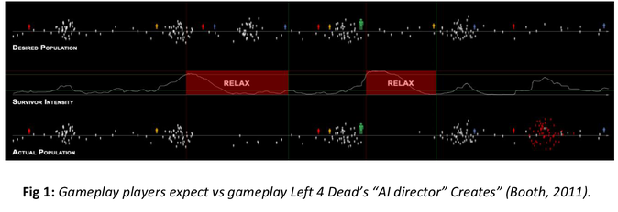

As the examples above show making games unfair can be fun by making them challenging and the role of a GM makes the game personalized. Figure 1 shows the emotional response players feel from Valves AI director controlling the game, using software that records user’s emotions such as Affectiva’s Affdex to record player’s emotions (Affectiva, 2016), a similar graph can be drawn up to make an interesting evaluation, as well as using Bartle’s player types to allow for more comparison (Bartle, 1996).

## 1.2 Motivation

### 1.2.1 Game design in terms of balance and fun

There are two main motivations for this project the first being the idea of designing games to be balanced and fun. Designing fun games isn’t something new to the industry, however allowing users to play in unfair environments is.

### 1.2.2 Virtual Reality and Asymmetrical games becoming more popular

The justification for using Virtual reality is that it would make the game asymmetric as well as removing eye contact and immersing the player like those of who play D&D. This was chosen over a symmetrical game as they allow for more option in terms of adding balance. MAYBE PUT ABOVE.

## 1.3 Aims and Objectives

An Asymmetrical multiplayer game is to be created, allowing one player to control game elements from a PC and the other play to be immersed in the game via virtual reality. This will be a purely competitive game allowing for discussion on whether competiveness affects player’s responses (Weibel et al., 2008).

### 1.3.1 Aims

The Aim of the project is to evaluate user’s responses when being put in a Game Master position with a specifically custom made game that has both a balanced and imbalanced version. This will look to see how the players ultimately react and how they make the game experience for the other player. This will use both the game play the players creates as well as the player’s emotional responses and other player metrics to assess the conclusion of the project. INFLUENCED BY DUNGEONS AND DRAGON INTERPRETATIONS OF RULES

### 1.3.2 Objectives TALK ABOUT AFFECTIVA BEFORE HERE

The Aim will be accomplished by these objectives;

1. Develop a Virtual Reality capable game with enough content to effectively evaluate the goal of the project. The game being a two player asymmetrical competitive game.
2. Recruit a decent sized participant pool, approximately 20+ to make for a solid conclusion. These participants will take a Bartle’s player type test adding another depth to the results, allowing for an in depth discussion in the evaluation.
3. Run a preliminary testing phase after game development to assess the suitability of the created game using both quantitative and qualitative methods.
4. Run two more testing phases. This will consist of 3 groups, group one playing the balanced, group 2 playing the imbalanced and group 3 being a control group (Details of this discussed HERE). These will switch for the third iteration. This is being done to insure that playing the previous versions of the game don’t influence player choices. Quantitative and qualitative methods will be used alongside Affdex, which will record players emotional and behavioural information, to provide solid results for the conclusion to this project (Affectiva, 2016).
5. Evaluate and summarise the results of the project
6. Perform a critical evaluation of the project